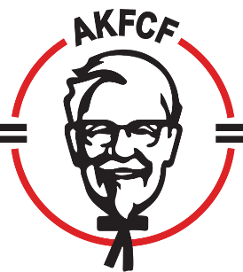

2021 Fall Regional meetings
Northeast Region Board meeting September 20-23 – Springfield, MA
Super Regional September 27-30 Hyatt Regency Tamaya – Albuquerque, NM
Southeastern Region Fall meeting – October 17-20 Charlotte, NC.
NW/SC virtual fall meeting – October 26-27
2022 Spring Regional meetings
NW/SW Spring RGM meeting – April 11-13 Vegas
SoCal Spring meeting – May 17th
Northeast Spring RGM meeting – May 9-12 Caesar’s Atlantic City, NJ
AKFCF 2022 Spring Meeting May 24 – 26, 2022 Marriott River Center, San Antonio, TX
RGM Connect Meeting June 13 – 14, 2022 Virtual – Tentative!

2022 Fall Regional meetings
AKFCF 2022 Fall Board Meeting - TBD
SC/NW Fall meeting – October 22-28 Hawaii
Super Regional – Tradewinds - October 9-14 St. Pete Beach, FL.
Southeastern Fall meeting – Oct 16-19 Hyatt Nashville, TN
Northeast Fall Board meeting - September 19 – 22, 2022 - TBD
2023 Spring Regional meetings
Northeast Spring RGM meeting – May 14-17 – Turning Stone - Verona, NY

2023 Fall Regional meetings
SC/NW – Sept.
Super Regional –
Southeast Fall meeting –
Northeast Fall Board meeting -

AKFCF Annual Conventions
- 2022 March 7-10 Gaylord Palms, Orlando, FL.
- 2023 Feb. 26 – Mar. 1 The JW Marriott, Austin, TX
- 2024 March 19 – 22 ARIA Las Vegas, NV (Contract Pending)

- 2025 January 26 – 29 The Gaylord Opryland Resort Nashville, TN

- 2026 February 23 – 26 The Gaylord National Resort Washington, DC

